The Attic

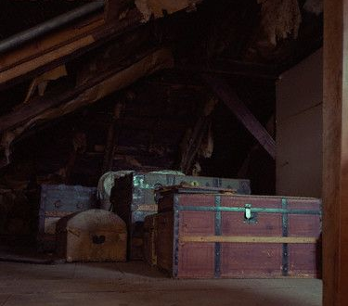
The stairs to the attic always creaked, but Vicky and Tommy knew where not to tread. Vicky led the way and her brother nervously followed. She was desperate to reach the top and open the forbidden door. Their Great Aunt Lucy was tending her herb garden so they had an hour at least to explore or so they thought.
Vicky reached the wooden, panelled door, she dived into her pocket and found the long brass key, slotted it into the waiting lock and excitedly turned. Anxiously Tommy waited, half hoping the key wouldn’t turn. The forbidden door opened invitingly and Vicky peered in through the crack…

Task:
To write the next section of the story.
Talk through your story.
You could make a picture gram of your story.
For each section/paragraph you could use key words or sentence starts.
What happened next?
- Describe the attic: dusty, dirty, ancient, dark, neglected, cobwebs, massive, enormous, ferocious, black, spider, corner, boxes, trunk, floorboards.
- How did the children feel?
Vicky: excited, curious, eager, thrilled.
Tommy: frightened, nervous, anxious, jumpy, uneasy, edgy, worried.
- What did the children do?
Opened the largest trunk.
Lid, pushed, forced, creaked, jammed.
- What was in the trunk?
A body, a skeleton, a gun, a knife, blood stained clothes, money, gold bars, diamonds and jewels, an old book.
- They hear someone/something climbing the stairs…
Easy sentence starts:
First… Next… Then… Suddenly
Or
Cautiously they… Quietly… In the corner… Carefully…
Suddenly… Quickly… Amazingly… Great Aunt Lucy appeared…

