BTEC – Home Cooking Skills
Contact Information: Mrs E Mendelson
Course Content
The aim of the qualification is to give every young person the basic skills and knowledge to be able to cook for themselves in a healthy and cost-effective way for the rest of their lives, as well as gain the confidence to share these skills with friends and family.
The course consists of many everyday recipes, all divided into manageable sections and covering key topics from eggs and baking to vegetables and quick-cook meats. This is all supported by learning range of facts that deal with other basics and essentials such as:
• Kitchen basics: what equipment you need and the best way to stock your store cupboard, fridge and freezer
• Food safety and hygiene: knife safety, fridge management and rotation
• How to shop cleverly: shopping lists, seasonal food, planning ahead
• Preparing ingredients and how to understand confusing food labels.
Qualification profile:
• Consists of two single unit BTEC qualifications at Level 1 and Level 2
• Both qualifications are fully funded on the QCF and contribute to Performance Points
Level 1 | Contributes to Foundation Learning provision | Focuses on giving young people the skills to prepare delicious and nutritious home-cooked food - using fresh ingredients - as well as an understanding of the value of passing on cooking knowledge
Level 2 | Equivalent to half a GCSE | Develops the student's ability to plan and prepare a series of nutritious home-cooked meals for breakfast, snacks, lunch and dinner, and helps them understand how to cook economically

For more information, visit
http://www.edexcel.com/quals/skills/home-cooking/Pages/default.aspx
Further Information

By studying Food technology you could get a job as a:

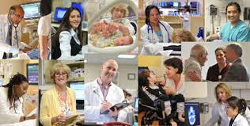
Health and Well-being:
- Dietician
- Environmental Health
- Officer
- Health Promotion Specialist
- Nutritionist
- Personal Trainer
- Food Development and

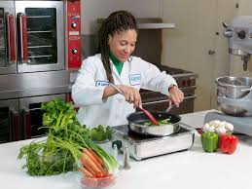
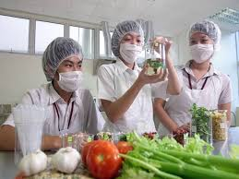
Production:
- Consumer Scientist
- Food Laboratory Technician
- Food Processing Worker
- Food Scientist/Technologist

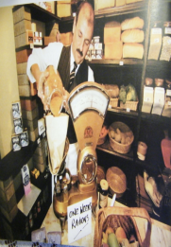
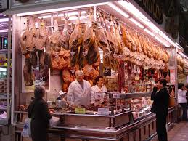
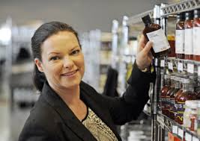
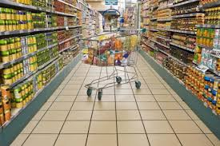
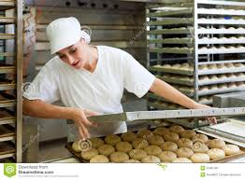
Food Retail:
- Baker
- Butcher
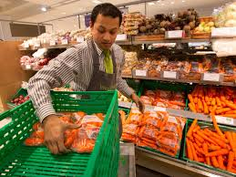
- Food Buyer
- Retail Manager
- Shopkeeper

BTEC Level 1 RECIPES BTEC Level 2 RECIPES
P:\Staff Room\FOOD TECHNOLOGY\BTEC LEVEL 1 RECIPES 2019 2020.pptx P:\Staff Room\FOOD TECHNOLOGY\BTEC LEVEL 2 RECIPES 2019 20.pptx

