PSE 5800 Worksheet

Unit 11 Being a Critical Consumer
Entry 2 (BCCE2)

Student name | Student number
Centre name | Centre number

Notes to teachers and students

This worksheet is for the amended PSE 5800 specification for teaching from September 2017.

If any of the Learning Outcomes and Assessment Criteria has been amended, the changes will be listed here:

- Learning Outcomes amended: 5 and 6
- Assessment Criteria amended: 1.1, 3.1, 4.1, 5.1, 5.2 and 6.1

This document has been created in Word to enable users to expand the text boxes.
All images © Thinkstock
Entry 2 (BCCE2)

Teacher checklist

Learning Outcomes |  | Assessment Criteria |  | Achieved  Yes / No (date)
The learner will: |  | The learner can:
1. | Know what is meant by ‘impulse buying’ and ‘shopping around’. | 1.1 | Identify an example of ‘impulse buying’ and an example of ‘shopping around’.
2. | Know some ways supermarkets seek to maximise sales. | 2.1 | Identify three ways by which supermarkets encourage customers to spend more money.
3. | Be able to compare prices from different suppliers. | 3.1 | Compare the prices of two common household items from two different suppliers, eg local shop, supermarket, on-line retailer.
4. | Know there are sources of information to assist the consumer. | 4.1 | Identify one source of information to assist with sensible buying, eg consumer magazines, price comparison websites.
5. | Know about basic customer rights in relation to buying in shops. | 5.1 | Communicate one circumstance in which customers have the right to a refund on goods purchased in a shop and one circumstance in which they do not.
 |  | 5.2 | Communicate one thing customers can do if they are not satisfied with the way a shop deals with a complaint.

1.1

Give an example of ‘impulse buying’ and an example of ‘shopping around’.

Impulse buying

Shopping around

2.1

Identify three ways by which supermarkets encourage customers to spend more money.

Look at the pictures below and circle three ways by which supermarkets encourage customers to spend more money

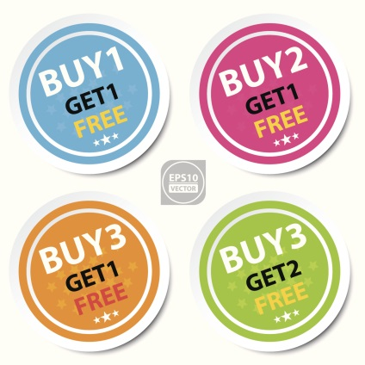

Buy 1 get 1 free offers Having products at the checkout

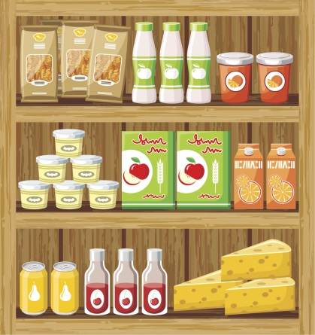

Placing expensive items at eye-level Keeping shelves fully stocked

3.1

Compare the prices of two common household items from two different suppliers, eg local shop, supermarket, on-line retailer.

Choose two common household items and compare their prices from two different suppliers.

Item 1
Supplier 1 | Price
Supplier 2 | Price

Item 2
Supplier 1 | Price
Supplier 2 | Price

4.1

Identify one source of information to assist with sensible buying, eg consumer magazines, price comparison websites.

Name of one place where you can find information about a product.

5.1

Communicate one circumstance in which customers have the right to a refund on goods purchased in a shop and one circumstance in which they do not.

Right to a refund:

No right to a refund:

5.2

Communicate one thing customers can do if they are not satisfied with the way a shop deals with a complaint.

If I am not happy with a complaint I made, I can …

Teacher comments
Signed | Date:

